**CHARTING THE COURSE OF INNOVATIVE: A STARTUP ANALYSIS**

INTRODUCTION

Overview:

* Starting a new company can be an exciting and rewarding experience, but it also requires careful planning and analysis to ensure that the business is viable and successful. There are several key areas that you should focus on when conducting a startup company analysis. Conducting a thorough analysis of these areas can help you identify potential challenges and opportunities, and develop strategies to address them. It is also important to regularly review and update your analysis as the business progresses, in order to adapt to changing market conditions.

Purpose:

* The purpose of analyzing innovation in start-ups is to understand and evaluate the unique and creative approaches that start-up companies take to develop and bring new products, services, or business models to the market. Innovation is a crucial element for the success of start-ups as it enables them to differentiate themselves, solve problems, create value, and disrupt traditional markets. Start-ups often face challenges such as limited resources, competition, and changing market dynamics, and innovation can be a key driver for their growth and sustainability.
* Analyzing innovation in start-ups serves several purposes, including:
* Identifying competitive advantage: Innovation allows start-ups to develop unique value propositions that differentiate them from competitors. By analyzing the innovation strategies and capabilities of start-ups, stakeholders can identify the specific advantages that make them stand out in the market.
* Evaluating market potential: Innovation in start-ups often involves identifying unmet customer needs or creating new markets. Analyzing the innovation efforts of start-ups helps in evaluating the potential of their products, services, or business models in the target market, and assessing the market demand and size.
* Assessing viability and scalability: Innovation is not only about creating new ideas but also about implementing them successfully. Analyzing the innovation strategies and execution plans of start-ups helps in assessing the viability and scalability of their innovation initiatives, which is critical for long-term success.
* Managing risk: Start-ups are inherently risky, and innovation involves taking risks. By analyzing the innovation efforts of start-ups, stakeholders can assess the risks associated with their innovation strategies, such as technological, market, regulatory, and financial risks, and make informed decisions to manage and mitigate those risks.
* Attracting investment and resources: Innovation is often a key factor that attracts investment and resources to start-ups. By analyzing the innovation capabilities and potential of start-ups, investors, partners, and other stakeholders can make informed decisions about allocating resources, funding, and support to help start-ups achieve their innovation goals.
* Driving continuous improvement: Start-ups need to continuously innovate and adapt to changing market conditions to remain competitive. By analyzing the innovation processes and outcomes of start-ups, stakeholders can identify areas of improvement and provide feedback to drive continuous innovation and refinement in their strategies and operations.
* In summary, the purpose of analyzing innovation in start-ups is to understand, evaluate, and leverage their unique approaches to create value, drive growth, and achieve long-term success in a dynamic and competitive business environment.

PROBLEM DEFINITION & DESIGN THINKING

Empathy map:

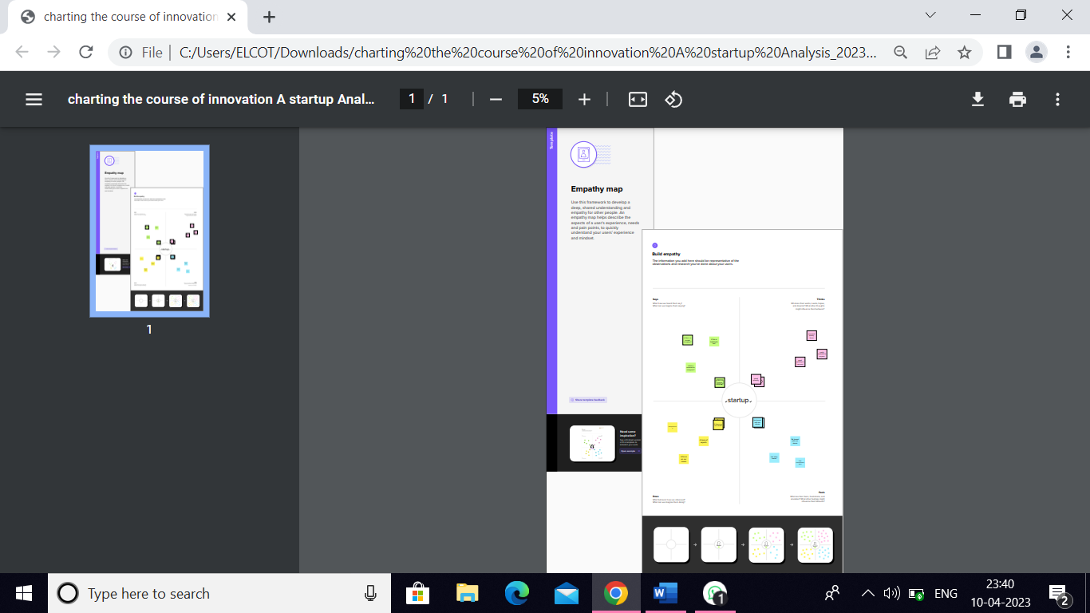

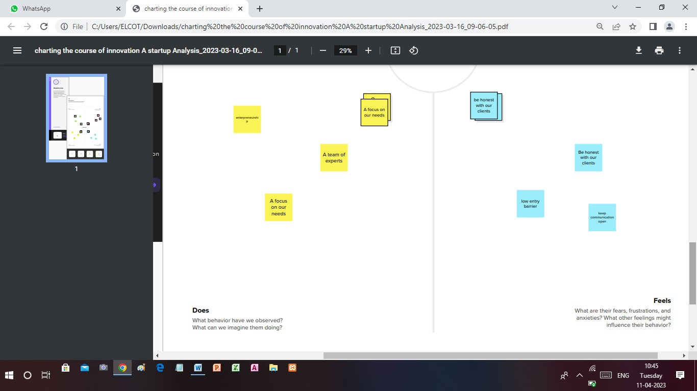

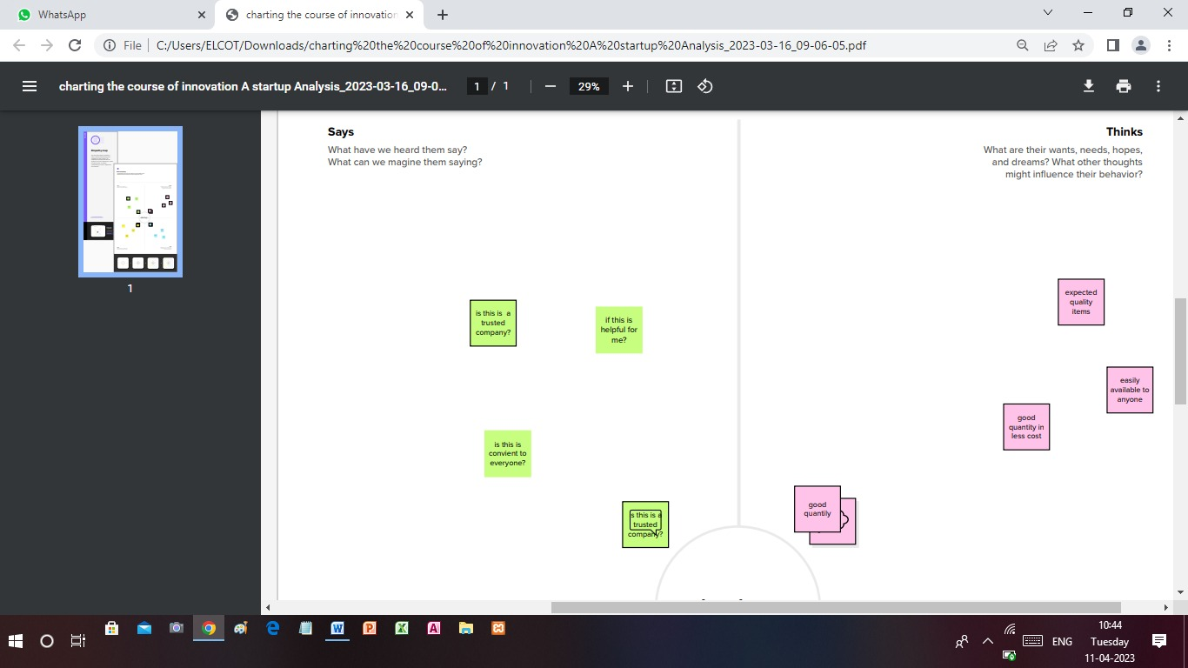

Ideation & Brainstorming map:

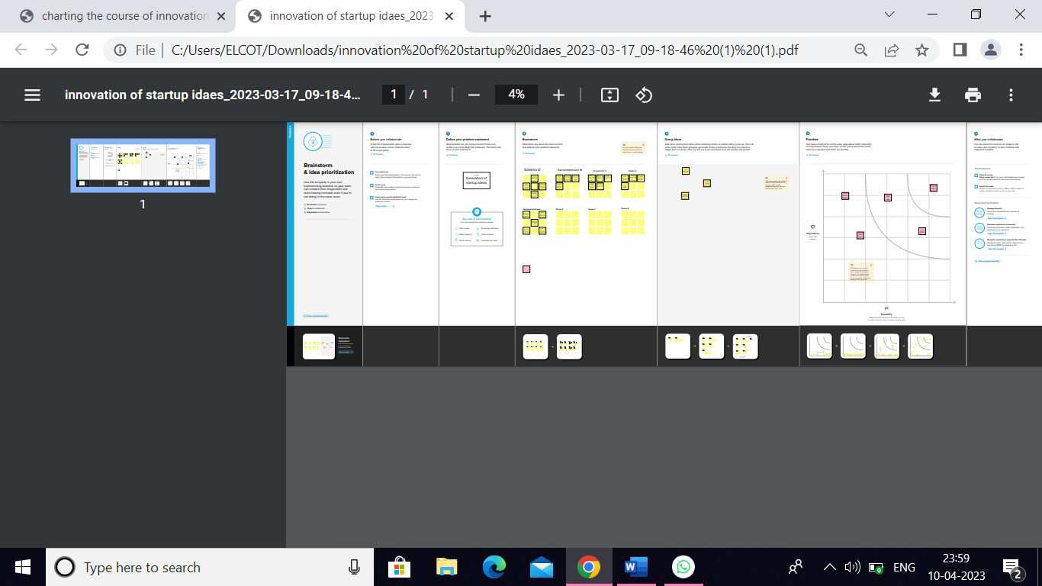

RESULT

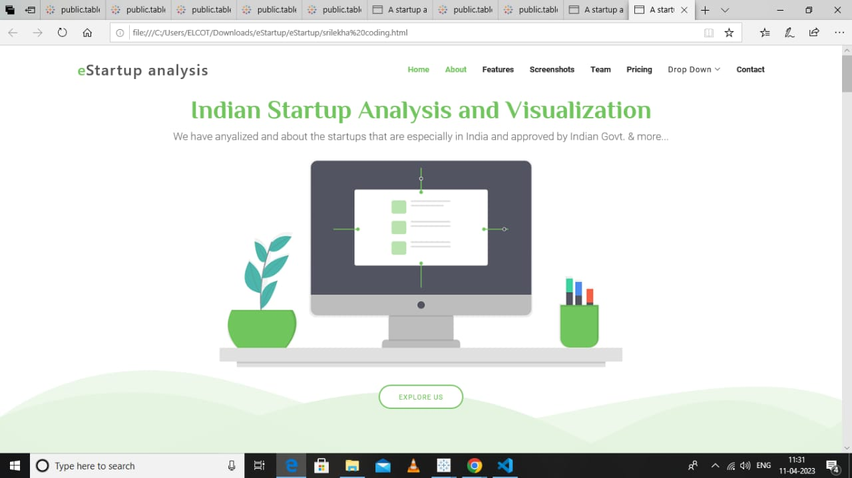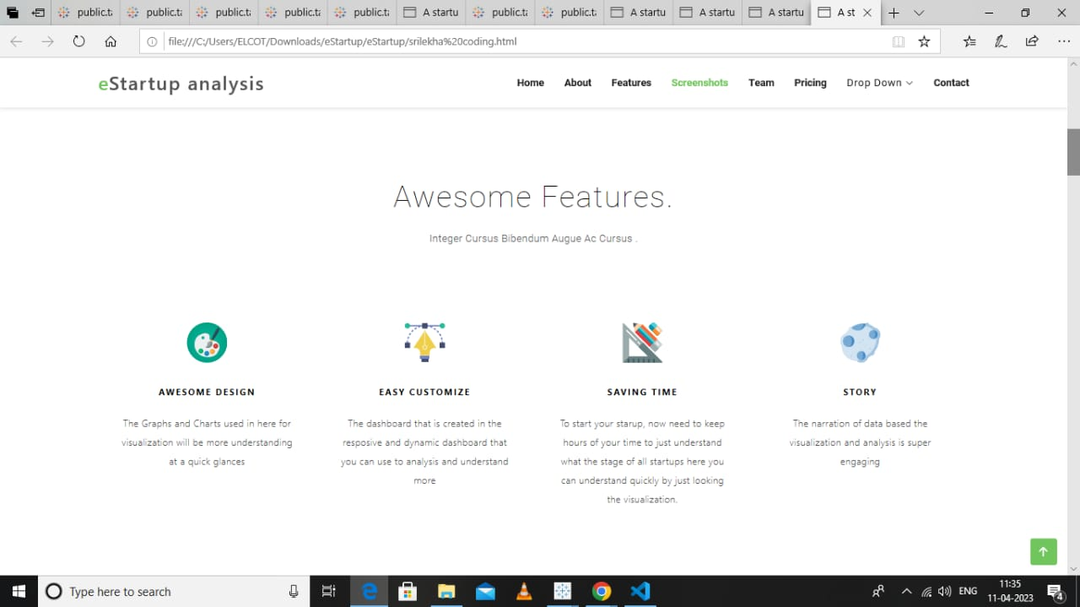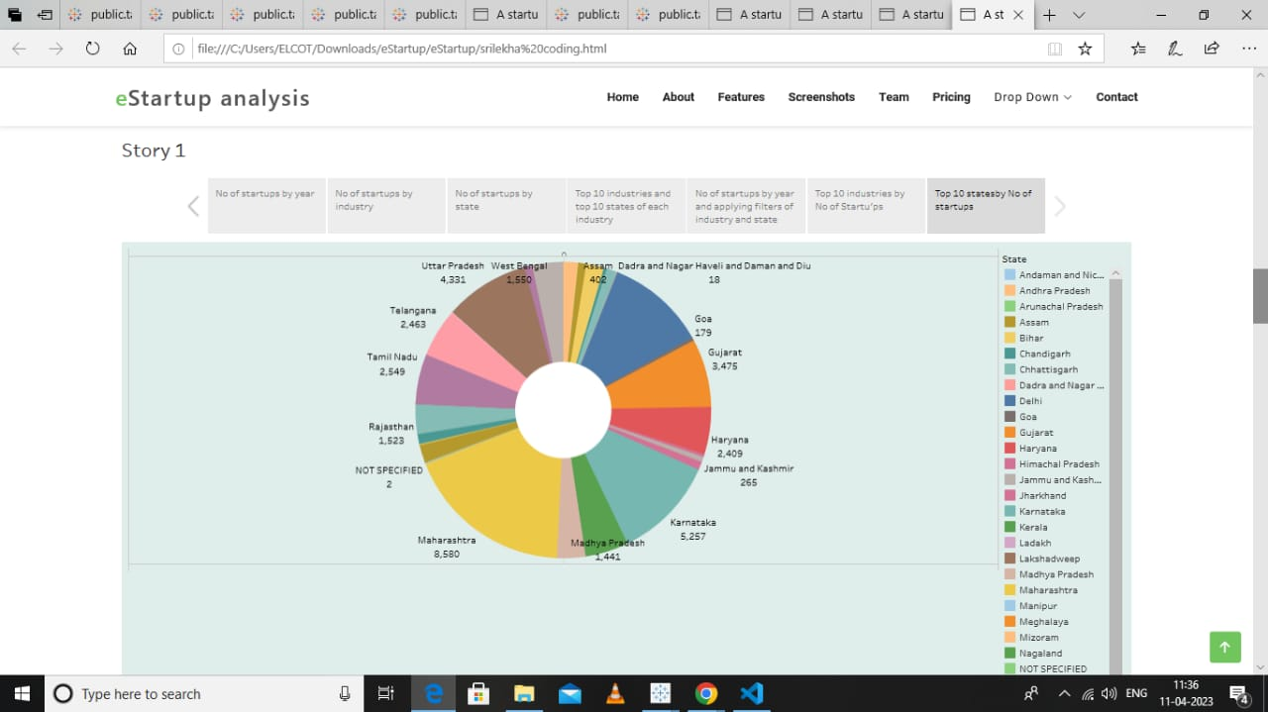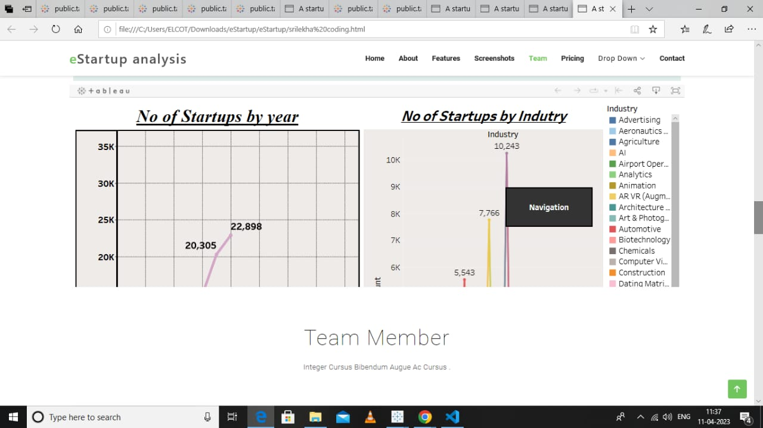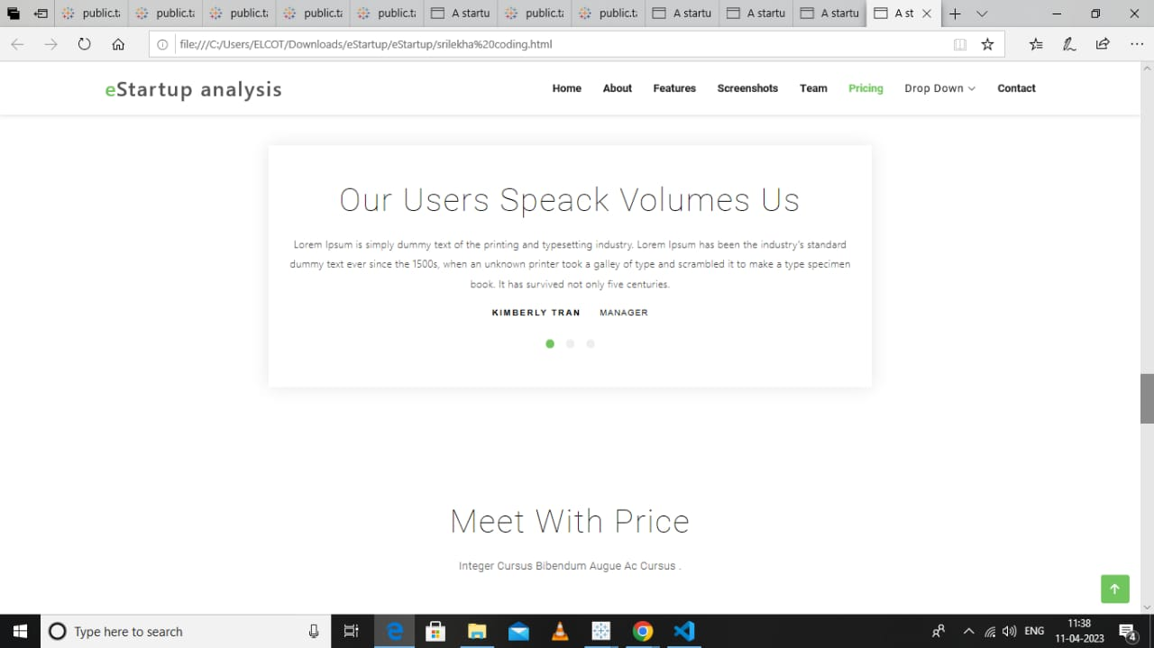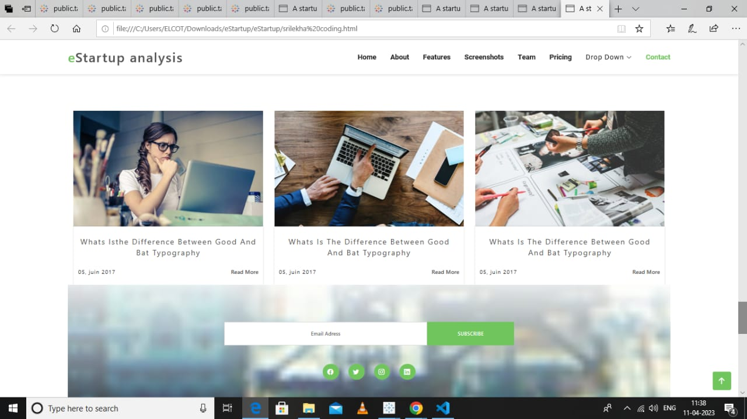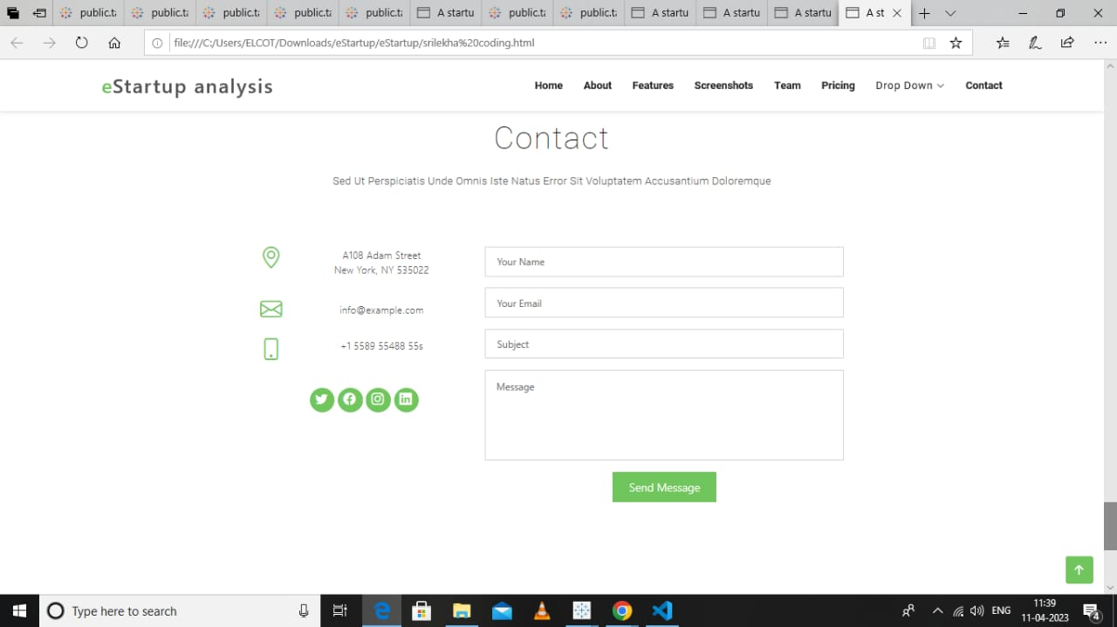

ADVANTAGES AND DISADVANTAGES

Advantages:

* Identifying new and emerging trends: By analyzing innovation in start-ups, businesses can identify new and emerging trends in their industry. This allows them to stay ahead of the competition and adapt their strategies to take advantage of new opportunities.
* Improving decision-making: Analyzing innovation in start-ups provides businesses with valuable insights into what works and what doesn't. This helps businesses make more informed decisions about their own innovation strategies.
* Finding potential investment opportunities: Start-ups are often seen as a source of innovation and disruption, and analyzing them can help investors identify potential investment opportunities.
* Developing new products and services: By analyzing the innovation strategies of start-ups, businesses can identify new and innovative ideas for products and services. This can help them create new revenue streams and stay ahead of the competition.
* Encouraging a culture of innovation: By analyzing the innovation strategies of start-ups, businesses can foster a culture of innovation within their own organization. This can lead to increased creativity, productivity, and ultimately, profitability.
* Overall, analyzing innovation in start-ups can provide businesses with valuable insights that can help them stay ahead of the competition and succeed in today's rapidly changing business environment.

Disadvantages:

* One disadvantage of innovation in start-up analysis is that it can be difficult to accurately predict the success of a new venture. Many innovative start-ups fail, even with a promising business model and a talented team, due to factors such as market conditions, competition, and funding issues. This makes it challenging for investors and analysts to accurately assess the potential of new start-ups, which can lead to a high degree of risk and uncertainty.
* Another potential disadvantage is that the process of innovation itself can be time-consuming and costly. It requires significant resources and investment in research and development, as well as the acquisition and analysis of data. This can be particularly challenging for smaller start-ups that may have limited resources and may struggle to compete with larger, more established companies.
* Finally, there is a risk that the focus on innovation can lead to a neglect of other important factors in start-up analysis, such as the quality of the management team, the scalability of the business model, and the potential for sustainable growth. While innovation is an important factor in the success of many start-ups, it should not be the sole focus of analysis.

APPLICATIONS

* The application of innovation in start-up analysis can provide valuable insights into the success or failure of a start-up. Some ways innovation can be applied to start-up analysis include:
* Identifying emerging trends: Start-up analysis can help identify emerging trends in the industry, and innovation can be used to identify start-ups that are leading these trends. By analyzing the technology and business models of these start-ups, investors can gain insights into future market trends.
* Evaluating disruptive technologies: Disruptive technologies can completely transform industries and create new opportunities for start-ups. By analyzing start-ups that are working on disruptive technologies, investors can assess the potential impact of these technologies on the market.
* Assessing business models: Innovation can be applied to analyze start-up business models to determine their viability and potential for growth. This can involve evaluating new revenue streams, cost structures, and customer acquisition strategies.
* Improving decision-making: Innovation can be used to improve the decision-making process for investors and entrepreneurs. By applying data analytics and machine learning techniques to start-up analysis, investors can make more informed decisions about which start-ups to invest in.
* The application of innovation to start-up analysis can provide valuable insights into the potential success or failure of a start-up. By leveraging data analytics and machine learning techniques, investors and entrepreneurs can make more informed decisions and improve their chances of success.

CONCLUSION

* Analyzing innovation in start-ups can provide businesses with valuable insights that can help them stay ahead of the competition and succeed in today's rapidly changing business environment.
* There is a risk that the focus on innovation can lead to a neglect of other important factors in start-up analysis, such as the quality of the management team, the scalability of the business model, and the potential for sustainable growth. While innovation is an important factor in the success of many start-ups, it should not be the sole focus of analysis.
  + - The application of innovation to start-up analysis can provide valuable insights into the potential success or failure of a start-up. By leveraging data analytics and machine learning techniques, investors and entrepreneurs can make more informed decisions and improve their chances of success.
* The future of startup analysis is likely to be driven by advancements in technology and data analytics. Startups that can leverage these tools to gain insights into their business and make data-driven decisions will be well-positioned for success.
* The purpose of analyzing innovation in start-ups is to understand, evaluate, and leverage their unique approaches to create value, drive growth, and achieve long-term success in a dynamic and competitive business environment.

FUTURE SCOPE

* The future scope of innovation in startup analysis is vast and constantly evolving as technology and business practices continue to evolve. Here are some potential areas of innovation:
* Artificial Intelligence and Machine Learning: AI and ML can be used to analyze large amounts of data from various sources and provide valuable insights into startup performance, market trends, and customer behavior. This can help startups make data-driven decisions and identify areas for improvement.
* Blockchain technology: Blockchain technology has the potential to revolutionize the way startups are funded, tracked, and evaluated. It provides transparency and accountability, making it easier for investors to evaluate the potential of a startup.
* Predictive Analytics: Predictive analytics can be used to identify patterns and trends that can help startups predict future outcomes. This can be particularly useful in the early stages of a startup's development when there is limited historical data available.
* Social Media Analytics: Social media analytics can be used to understand customer behavior, preferences, and opinions. This can help startups refine their marketing strategies and improve their customer engagement.
* Cloud-based solutions: Cloud-based solutions can provide startups with a cost-effective and scalable way to manage their data and analytics. This can be particularly beneficial for startups that are operating with limited resources.
* Overall, the future of startup analysis is likely to be driven by advancements in technology and data analytics. Startups that can leverage these tools to gain insights into their business and make data-driven decisions will be well-positioned for success.

APPENDIX

Source Code:

<!DOCTYPE html>

<html lang="en">

<head>

<meta charset="utf-8">

<meta content="width=device-width, initial-scale=1.0" name="viewport">

<title>A startup analysis coding</title>

<meta content="" name="description">

<meta content="" name="keywords">

<!-- Favicons -->

<link href="assets/img/favicon.png" rel="icon">

<link href="assets/img/apple-touch-icon.png" rel="apple-touch-icon">

<!-- Google Fonts -->

<link href="https://fonts.googleapis.com/css?

family=Open+Sans:300,300i,400,400i,700,700i|Roboto:100,300,400,500,700|Philosopher:400,400i,700,700i" rel="stylesheet">

<!-- Vendor CSS Files -->

<link href="assets/vendor/aos/aos.css" rel="stylesheet">

<link href="assets/vendor/bootstrap/css/bootstrap.min.css" rel="stylesheet">

<link href="assets/vendor/bootstrap-icons/bootstrap-icons.css" rel="stylesheet">

<link href="assets/vendor/glightbox/css/glightbox.min.css" rel="stylesheet">

<link href="assets/vendor/swiper/swiper-bundle.min.css" rel="stylesheet">

<!-- Template Main CSS File -->

<link href="assets/css/style.css" rel="stylesheet">

<!-- =======================================================

* Template Name: eStartup

* Updated: Mar 10 2023 with Bootstrap v5.2.3

* Template URL: https://bootstrapmade.com/estartup-bootstrap-landing-page-template/

* Author: BootstrapMade.com

* License: https://bootstrapmade.com/license/

======================================================== -->

</head>

<body>

<!-- ======= Header ======= -->

<header id="header" class="header fixed-top d-flex align-items-center">

<div class="container d-flex align-items-center justify-content-between">

<div id="logo">

<h1><a href="index.html"><span>e</span>Startup analysis</a></h1>

<!-- Uncomment below if you prefer to use an image logo -->

<!-- <a href="index.html"><img src="assets/img/logo.png" alt="" title="" /></a>-->

</div>

<nav id="navbar" class="navbar">

<ul>

<li><a class="nav-link scrollto active" href="#hero">Home</a></li>

<li><a class="nav-link scrollto" href="#about-us">About</a></li>

<li><a class="nav-link scrollto" href="#features">Features</a></li>

<li><a class="nav-link scrollto" href="#screenshots">Screenshots</a></li>

<li><a class="nav-link scrollto" href="#team">Team</a></li>

<li><a class="nav-link scrollto" href="#pricing">Pricing</a></li>

<li class="dropdown"><a href="#"><span>Drop Down</span> <i class="bi bi-chevron-down"></i></a>

<li><a class="nav-link scrollto" href="#contact">Contact</a></li>

</ul>

<i class="bi bi-list mobile-nav-toggle"></i>

</nav><!-- .navbar -->

</div>

</header><!-- End Header -->

<!-- ======= Hero Section ======= -->

<section id="hero">

<div class="hero-container" data-aos="fade-in">

<h1>Indian Startup Analysis and Visualization</h1>

<h2>We have anyalized and about the startups that are especially in India and approved by Indian Govt. &amp; more...</h2>

<img src="assets/img/hero-img.png" alt="Hero Imgs" data-aos="zoom-out" data-aos-delay="100">

<a href="#get-started" class="btn-get-started scrollto">Explore Us</a>

<div class="btns">

</div>

</section><!-- End Hero Section -->

<main id="main">

<!-- ======= Get Started Section ======= -->

<section id="get-started" class="padd-section text-center">

<div class="container" data-aos="fade-up">

<div class="section-title text-center">

<!-- ======= About Us Section ======= -->

<section id="about-us" class="about-us padd-section">

<div class="container" data-aos="fade-up">

<div class="row justify-content-center">

<div class="col-md-5 col-lg-3">

<div class="col-md-7 col-lg-5">

<div class="about-content" data-aos="fade-left" data-aos-delay="100">

</div>

</div>

</div>

</section><!-- End About Us Section -->

<!-- ======= Features Section ======= -->

<section id="features" class="padd-section text-center">

<div class="container" data-aos="fade-up">

<div class="section-title text-center">

<h2>Awesome Features.</h2>

<p class="separator">Integer cursus bibendum augue ac cursus .</p>

</div>

<div class="row" data-aos="fade-up" data-aos-delay="100">

<div class="col-md-6 col-lg-3">

<div class="feature-block">

<img src="assets/img/svg/paint-palette.svg" alt="img">

<h4>Awesome design</h4>

<p>The Graphs and Charts used in here for visualization will be more understanding at a quick glances</p>

</div>

</div>

<div class="col-md-6 col-lg-3">

<div class="feature-block">

<img src="assets/img/svg/vector.svg" alt="img">

<h4>Easy Customize</h4>

<p>The dashboard that is created in the resposive and dynamic dashboard that you can use to analysis and understand

more</p>

</div>

</div>

<div class="col-md-6 col-lg-3">

<div class="feature-block">

<img src="assets/img/svg/design-tool.svg" alt="img">

<h4>Saving Time</h4>

<p>To start your starup, now need to keep hours of your time to just understand what the stage of all startups here you can

understand quickly by just looking the visualization.</p>

</div>

</div>

<div class="col-md-6 col-lg-3">

<div class="feature-block">

<img src="assets/img/svg/asteroid.svg" alt="img">

<h4>Story</h4>

<p>The narration of data based the visualization and analysis is super engaging</p>

</div>

</div>

<div

</div>

</section><!-- End Features Section -->

<!-- ======= Screenshots Section ======= -->

<section id="screenshots" class="padd-section text-center">

<div class="container" data-aos="fade-up">

<div class="section-title text-center">

<h2>App Gallery</h2>

<p class="separator">Integer cursus bibendum augue ac cursus .</p>

</div>

<div class="screens-slider swiper">

<div class="swiper-wrapper align-items-center">

<div class="swiper-slide"><img src="assets/img/screen/1.jpg" class="img-fluid" alt=""></div>

<div class="swiper-slide"><img src="assets/img/screen/2.jpg" class="img-fluid" alt=""></div>

<div class="swiper-slide"><img src="assets/img/screen/3.jpg" class="img-fluid" alt=""></div>

<div class="swiper-slide"><img src="assets/img/screen/4.jpg" class="img-fluid" alt=""></div>

<div class="swiper-slide"><img src="assets/img/screen/5.jpg" class="img-fluid" alt=""></div>

<div class="swiper-slide"><img src="assets/img/screen/6.jpg" class="img-fluid" alt=""></div>

<div class="swiper-slide"><img src="assets/img/screen/7.jpg" class="img-fluid" alt=""></div>

<div class="swiper-slide"><img src="assets/img/screen/8.jpg" class="img-fluid" alt=""></div>